TOBAGO VICARIATE
HOLY WEEK, 2020 (1)

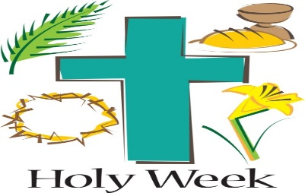

PALM SUNDAY OF THE PASSION OF THE LORD:

- PARISH OF ST. JOSEPH

- Saturday, April 04th, 2020, Procession followed by Mass, 6.00 p.m. For all communities

- Sunday, April 05th, 2020, Procession followed by Mass, 8.00 a.m. For all communities

- PARISH OF SACRED HEART

- Saturday, April 04th, 2020, 7.p.m. Mass, St. Dominic, Goodwood

- Sunday, April 05th, 2020, 8.30 a.m. Mass, Sacred Heart, Delaford.

HOLY THURSDAY:
- PARISH OF ST. JOSEPH/PARISH OF SACRED HEART:

- Thursday, April 09th, 2020, Mass for all communities, at 6.30 p.m. St. Joseph Roman Catholic Church, Scarborough

- Thursday, April 09th, Mass, for all communities, at 7.00 p.m. Sacred Heart Roman Catholic Church, Delaford

GOOD FRIDAY:
- PARISH OF ST. JOSEPH:

- Friday, April 10th, 2020, Good Friday Public Way of the Cross, 5.00 a.m. Starting point, St. Joseph Roman Catholic Church, Scarborough, to Our Lady of Lourdes Chapel, Patience Hill

- Friday, April 10th, 2020, Solemnity, 3.00 p.m. for all communities at St. Joseph Roman Catholic Church, Scarborough

- PARISH OF SACRED HEART:

- Friday, April 10th, Good Friday Public Way of the Cross, 5.00 a.m. from Sacred Heart Roman Catholic Church, Delaford, to Our Lady of the Assumption, Roxborough

- Friday, April 10th, Solemnity, 3.00 p.m. for all communities at the Sacred Heart Roman Catholic Church, Delaford.

GLORIOUS SATURDAY:

- PARISH OF ST. JOSEPH/SACRED HEART:

- Mass at St. Joseph Roman Catholic Church, Scarborough, for all communities, 6.30 p.m. Saturday, April 11th

- Mass at Sacred Heart, Delaford, 7.00 p.m. Saturday, April 11th

EASTER SUNDAY:
- PARISH OF SACRED HEART

- Mass at Our Lady of the Immaculate Assumption, Roxborough, 7.00 a.m. Sunday, April 12th

- Mass at Sacred Heart, Delaford, 8.30 a.m. Sunday, April 12th

- Mass at St. Dominic, Goodwood, 10.30 a.m., Sunday, April 12th

PARISH OF ST. JOSEPH:

- Mass at St. Joseph Roman Catholic, Scarborough, 8.30 a.m. Sunday, April 12th, for all communities

- Mass at Crown Point Beach Hotel, Crown Point, 11.00 a.m. Sunday, April 12th, 2020.

