TOBAGO VICARIATE
HOLY WEEK, 2018

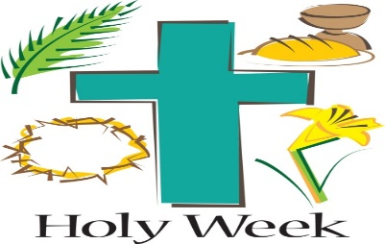

PALM SUNDAY OF THE LORDS’ PASSION:

- PARISH OF ST. JOSEPH:

- Saturday, March 24th, procession begins at 6.00 p.m. at Tambrin Square and ends with Mass at St. Joseph R.C. Church.

- Sunday, March 25th, procession begins at 8.00 a.m. at Tambrin Square and ends with Mass at St. Joseph R.C. Church.

- PARISH OF SACRED HEART:
Sunday, March 25th, procession begins at 8.30 a.m.at the Delaford Community Centre and culminates with Mass at the Sacred Heart R.C. Church.

HOLY THURSDAY:

- PARISH OF ST. JOSEPH/PARISH OF SACRED HEART:

- Thursday, March 29, Mass for all communities at 7.00 p.m. St. Joseph R.C. Church, Scarborough

- Thursday, March 29th, Mass for all communities at 7.00 p.m. Sacred Heart, Delaford

GOOD FRIDAY:
- PARISH OF ST. JOSEPH:

- Friday, March 30th, Good Friday Public Way of the Cross, 5.00 a.m. Starting point, Botanic Gardens (East) to the St. Joseph R.C. Church.

- Friday, March 30th, celebrations, 3.00 p.m. for all communities at St. Joseph R.C. Church, Scarborough

- PARISH OF SACRED HEART:

- Friday, March 25th, Good Friday Public Way of the Cross, 5.00 a.m. from Pembroke Heritage Park to St. Dominic, Goodwood.

- Friday, March 25th, celebrations, 3.00 p.m. for all communities at the Sacred Heart R.C. Church, Delaford.

GLORIOUS SATURDAY:

- PARISH OF ST. JOSEPH/SACRED HEART:

- Mass at St. Joseph R.C. for all communities, 6.30 p.m. Saturday, March 31st.

- Mass at Sacred Heart, for all communities, 8.00 p.m. Saturday, March 31st.

EASTER SUNDAY:

- PARISH OF SACRED HEART

- Mass at Our Lady of the Immaculate Assumption, Roxborough, 7.00 a.m. Sunday, April 1st, for all communities

- Mass at Sacred Heart, Delaford, 8.30 a.m. Sunday, April 1st, for all communities.

- Mass at St. Dominic, GoodWood, 10.30 a.m. Sunday, April 1st, for all communities

- PARISH OF ST. JOSEPH:

- Mass at St. Joseph R.C. Scarborough, 8.30 a.m. Sunday, April 1st, for all communities

- Mass at Crown Point Beach Hotel, Crown Point, 11.00 a.m. Sunday, April 1st, 2018.

